________________________________________________________________

A detailed report on Value Added course on

“CCNAV7: Introduction to Networks”

(05/06/2023 to 9/06/2023)

|  |  |  |  |  |  |  |
| --- | --- | --- | --- | --- | --- | --- |
| **Department** | **Title of the Value added Course** | **Name of the coordinator of the course** | **Duration** | **Name of the Resource Persons** | **No. of Students enrolled** | **No. of Students completed** |
| Computer Science and Engineering | Skill Oriented Course on “CCNAV7: Introduction to Networks” | Ms. Jeevana Jyothi, Assistant Professor of CSE, SRIT | 05/06/2023 to  09/06/2023 | Mr. M. Narasimhulu, Assistant Professor of CSE, SRIT | 72 | 72 |

## Introduction:

## Welcome to the Introduction to Networks (ITN) course. This course introduces the architecture, structure, functions, components, and models of the Internet and other computer networks. The principles and structure of IP addressing and the fundamentals of Ethernet concepts, media, and operations are introduced to provide a foundation for the curriculum. By the end of the course, students will be able to build simple local area networks (LAN), perform basic configurations for routers and switches, and implement IP addressing schemes.

## Hardware Requirements:

1. i3 or above Processor is required.
2. 4 GB RAM is recommended,
3. Good Internet Connectivity.
4. Disk space:40 GB

## Software Used:

1. Cisco Packet tracer 8.2

2. Google Chrome, Fire-Fox, Internet Explorer Latest version

3. OS: windows 10/Ubuntu 22.04

## Duration:

36 Hours (6 hours each day X 6 days) Offline

**Objectives of the course:**

1. Basic Knowledge about Networking.
2. Using Advanced tool Packet Tracer for Partical Purpose.

**Brochure of the course:**

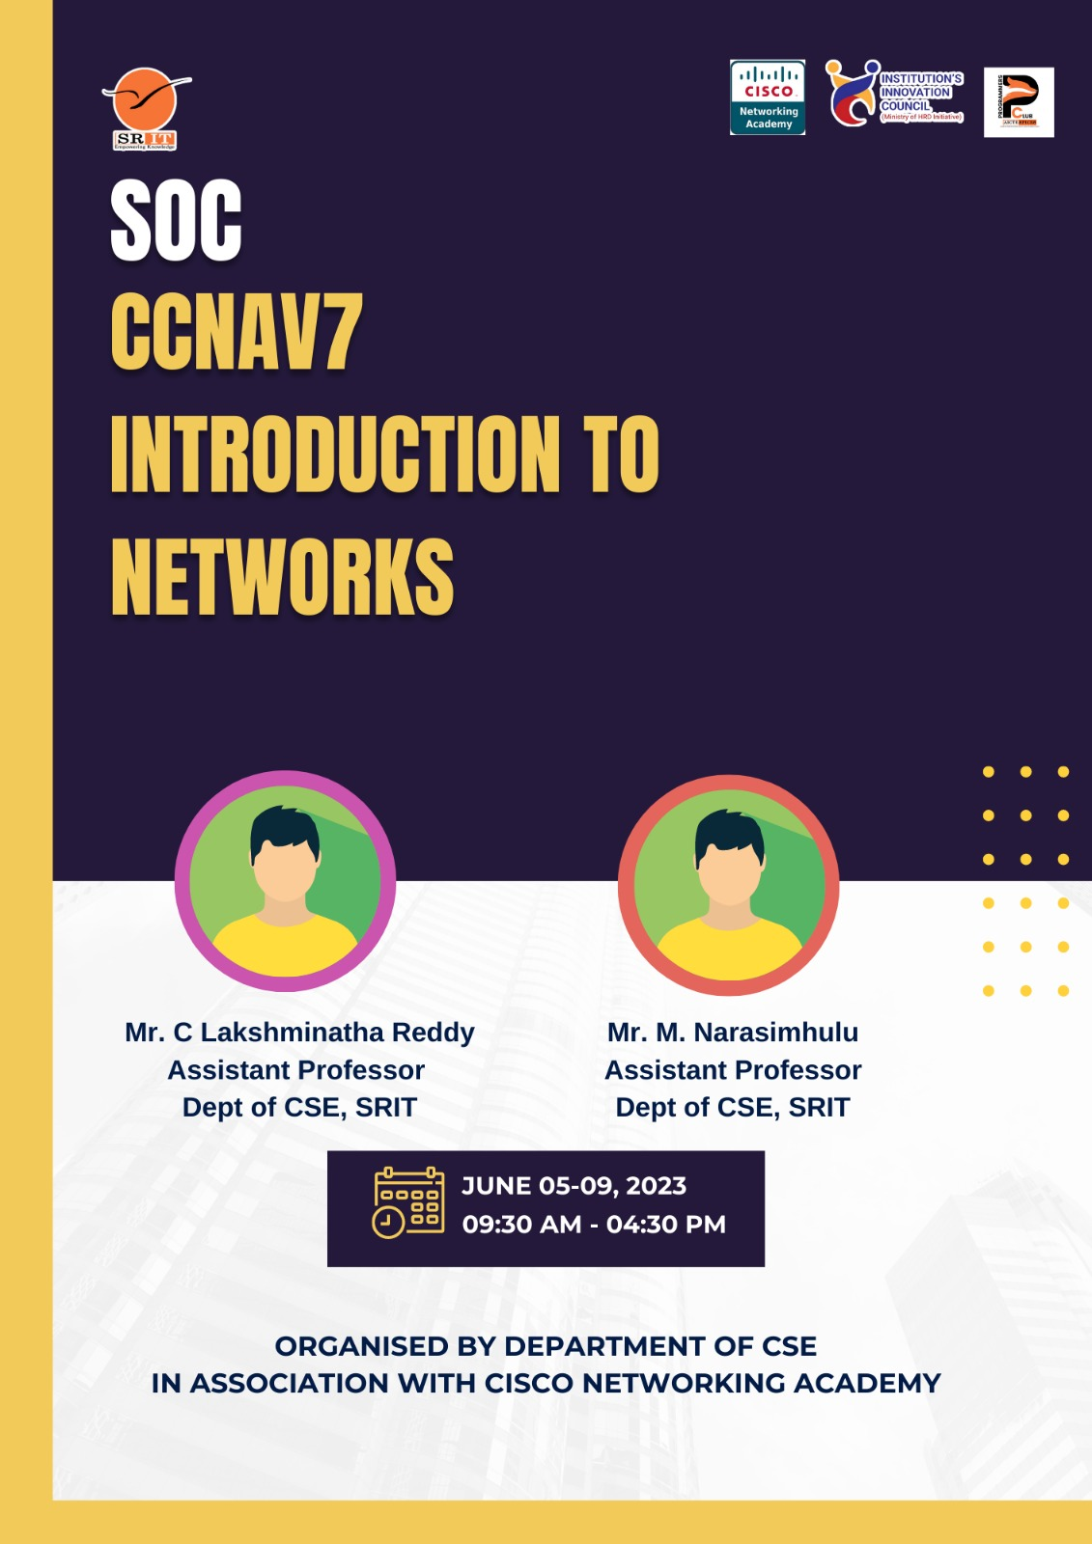

**Course Content: CCNAv7: Introduction to Networks:**

**Module 1: Networking Today**

Introduction, Networks Affect our Lives, Network Components, Network Representations and Topologies, Common types of Networks, Internet Connections, Reliable Networks, Network Trends, Network Security, The IT Professional.

**Module 2: Basic Switch and End Device Configuration**

Introduction, Cisco IOS Access, IOS Navigation, Command Structure, Basic Device Configuration,

Save Configuration, Ports and Address, Configure IP Addressing, Verify Connectivity.

**Module 3: Protocols and Models**

Introduction, The Rules, Protocols, Protocol Suites, Standard Organization, Reference Models, Data Encapsulation, Data Access.

**Module 4: Physical Layer**

Introduction, Purpose of the Physical Layer, Physical Layer Characteristics, Copper Cabling, UTP Cabling, Fiber-Optic, Wireless Media.

**Module 5: Number Systems**

Introduction, Binary Number System, Hexadecimal Number System.

**Module 6: Data Link Layer**

Introduction, Purpose of the Data Link Layer, Topologies, Data Link Frame.

**Module 7: Ethernet Switching**

Introduction, Ethernet Frames, Ethernet MAC Address, The MAC Address Table, Switch and Forwarding Methods.

**Module 8: Network Layer**

Introduction, Network Layer Characteristics, IPV4 Packet, IPV6 Packet, How a Host Routes, Introduction to Routing.

**Module 9: Address Resolution**

Introduction, MAC and IP, ARP, IPv6 Neighbour Discovery.

**Module 10: Basic Router Configuration**

Introduction, Configure Initial Routing Settings, Configure Interfaces, Configure the Default Gateway.

**Module 11: IPv4 Addressing**

Introduction, IPv4 Addressing Scheme, IPv4 Unicast, Broadcast, and Multicast; Types of IPv4 Addressing, Network Segmentation, Subnet an IPv4 Network, Subnet a Slash 16 and a Slash 8 Prefix, Subnet to meet Requirements, VLSM, Structured Design.

**Module 12: IPv6 Addressing**

Introduction, IPv4 Issues, IPv6 Representations, IPv6 Address Types, GUA and LLA Static Configuration, Dynamic Addressing for IPv6 GUAs, Dynamic Addressing for IPv6 LLAs, IPv6 Multicast Addresses, Subnet an IPv6 Network.

**Module 13: ICMP**

Introduction, ICMP Messages, Ping and Traceroute tests.

**Module 14: Transport Layer**

Introduction, Transportation of Data, TCP Overview, UDP Overview, Port Numbers, TCP communication Process, Reliability and Flow Control, UDP communication.

**Module 15: Application Layer**

Introduction, Application, Presentation, and Session; Peer-to-Peer, Web and Email Protocols, IP Addressing Services, File Sharing Services.

**Module 16: Network Security Fundamentals**

Introduction, Security Threats and Vulnerabilities, Network attacks, Network attack Mitigations, Device Security.

**Module 17: Build a small network**

Introduction, Devices in a small network, Small network applications and Protocols, Scale to Larger networks, verify connectivity, Host and IOS commands, Troubleshooting Methodologies, Troubleshooting Scenarios.

**Day wise Schedule:**

| **S. No.** | **Day** | **Timings** | **Course Content** |
| --- | --- | --- | --- |
| 1 | Mon | 9:30 AM  to  4:30 PM | Module 1: Networking Today,  Module 2: Basic Switch and End Device Configuration,  Module 3: Protocols and Models |
| 2 | Tue | 9:30 AM  to  4:30 PM | Module 4: Physical Layer,  Module 5: Number Systems, |
| 3 | Wed | 9:30 AM  to  4:30 PM | Module 7: Ethernet Switching,  Module 8: Network Layer,  Module 9: Address Resolution. |
| 4 | Thru | 9:30 AM  to  4:30 PM | Module 10: Basic Router Configuration,  Module 11: IPv4 Addressing,  Module 12: IPv6 Addressing. |
| 5 | Fri | 9:30 AM  to  4:30 PM | Module 14: Transport Layer,  Module 15: Application Layer. |
| 6 | Sat | 9:30 AM  to  4:30 PM | Module 16: Network Security Fundamentals,  Module 17: Build a small network. |

**List of students:**

| **S. No.** | **Year & Sem** | **Duration of workshop** | **H. T. Number** | **Name of the student** |
| --- | --- | --- | --- | --- |
| 1 | II B. Tech, II-Sem. | 5th – 10th, June, 2022 | 214G1A0564 | NADIRA ANJUM J |
| 2 | II B. Tech, II-Sem. | 5th – 10th, June, 2022 | 214G1A0565 | NAGA SHRAVAN B |
| 3 | II B. Tech, II-Sem. | 5th – 10th, June, 2022 | 214G1A0566 | NAGATEJADEEP REDDY B |
| 4 | II B. Tech, II-Sem. | 5th – 10th, June, 2022 | 214G1A0567 | NANDHINI M |
| 5 | II B. Tech, II-Sem. | 5th – 10th, June, 2022 | 214G1A0568 | NANDINI B |
| 6 | II B. Tech, II-Sem. | 5th – 10th, June, 2022 | 214G1A0569 | NARENDRA M |
| 7 | II B. Tech, II-Sem. | 5th – 10th, June, 2022 | 214G1A0570 | NAVADEEP REDDY V |
| 8 | II B. Tech, II-Sem. | 5th – 10th, June, 2022 | 214G1A0571 | NAVYASREE S |
| 9 | II B. Tech, II-Sem. | 5th – 10th, June, 2022 | 214G1A0572 | NEERAJ P |
| 10 | II B. Tech, II-Sem. | 5th – 10th, June, 2022 | 214G1A0573 | NEHA A |
| 11 | II B. Tech, II-Sem. | 5th – 10th, June, 2022 | 214G1A0574 | PALLAVI B |
| 12 | II B. Tech, II-Sem. | 5th – 10th, June, 2022 | 214G1A0575 | PALLAVI M (MANNELA) |
| 13 | II B. Tech, II-Sem. | 5th – 10th, June, 2022 | 214G1A0576 | PALLAVI M (MEENUGA) |
| 14 | II B. Tech, II-Sem. | 5th – 10th, June, 2022 | 214G1A0577 | PAVITRA K |
| 15 | II B. Tech, II-Sem. | 5th – 10th, June, 2022 | 214G1A0578 | PRABHAS REDDY R |
| 16 | II B. Tech, II-Sem. | 5th – 10th, June, 2022 | 214G1A0579 | PRASHANTH KUMAR REDDY P |
| 17 | II B. Tech, II-Sem. | 5th – 10th, June, 2022 | 214G1A0580 | PUJAN KUMAR M |
| 18 | II B. Tech, II-Sem. | 5th – 10th, June, 2022 | 214G1A0581 | RAMYASREE G |
| 19 | II B. Tech, II-Sem. | 5th – 10th, June, 2022 | 214G1A0582 | RANGA SAHITHI C |
| 20 | II B. Tech, II-Sem. | 5th – 10th, June, 2022 | 214G1A0583 | RAVITEJA M |
| 21 | II B. Tech, II-Sem. | 5th – 10th, June, 2022 | 214G1A0584 | REVATHI B |
| 22 | II B. Tech, II-Sem. | 5th – 10th, June, 2022 | 214G1A0585 | SAI DHANUSH D |
| 23 | II B. Tech, II-Sem. | 5th – 10th, June, 2022 | 214G1A0586 | SAI HARITHA G |
| 24 | II B. Tech, II-Sem. | 5th – 10th, June, 2022 | 214G1A0587 | SAI JAHNAVI G |
| 25 | II B. Tech, II-Sem. | 5th – 10th, June, 2022 | 214G1A0588 | SAI MEGHANA REDDY G |
| 26 | II B. Tech, II-Sem. | 5th – 10th, June, 2022 | 214G1A0589 | SAI PAVANI M |
| 27 | II B. Tech, II-Sem. | 5th – 10th, June, 2022 | 214G1A0590 | SAI PRASANNA C |
| 28 | II B. Tech, II-Sem. | 5th – 10th, June, 2022 | 214G1A0591 | SAI PREETHIKA G |
| 29 | II B. Tech, II-Sem. | 5th – 10th, June, 2022 | 214G1A0592 | SAI SARANYA P |
| 30 | II B. Tech, II-Sem. | 5th – 10th, June, 2022 | 214G1A0593 | SAMHITHA S |
| 31 | II B. Tech, II-Sem. | 5th – 10th, June, 2022 | 214G1A0594 | SAMYU J N |
| 32 | II B. Tech, II-Sem. | 5th – 10th, June, 2022 | 214G1A0595 | SASI VARUN KUMAR REDDY B |
| 33 | II B. Tech, II-Sem. | 5th – 10th, June, 2022 | 214G1A0596 | SHAGUPTHA NAAZ D |
| 34 | II B. Tech, II-Sem. | 5th – 10th, June, 2022 | 214G1A0597 | SHARAN KUMAR C |
| 35 | II B. Tech, II-Sem. | 5th – 10th, June, 2022 | 214G1A0598 | SHARON MELORA ANGEL Z |
| 36 | II B. Tech, II-Sem. | 5th – 10th, June, 2022 | 214G1A0599 | SHASHIKALA B |
| 37 | II B. Tech, II-Sem. | 5th – 10th, June, 2022 | 214G1A05A0 | SHEEBA SHAIK G |
| 38 | II B. Tech, II-Sem. | 5th – 10th, June, 2022 | 214G1A05A1 | SIREESHA P |
| 39 | II B. Tech, II-Sem. | 5th – 10th, June, 2022 | 214G1A05A2 | SIVA MANIKANTA B |
| 40 | II B. Tech, II-Sem. | 5th – 10th, June, 2022 | 214G1A05A3 | SNEHALATHA D |
| 41 | II B. Tech, II-Sem. | 5th – 10th, June, 2022 | 214G1A05A4 | SOBITHA RANI G |
| 42 | II B. Tech, II-Sem. | 5th – 10th, June, 2022 | 214G1A05A5 | SREEJA REDDY P |
| 43 | II B. Tech, II-Sem. | 5th – 10th, June, 2022 | 214G1A05A6 | SUJITH A |
| 44 | II B. Tech, II-Sem. | 5th – 10th, June, 2022 | 214G1A05A7 | SUMMIYA K |
| 45 | II B. Tech, II-Sem. | 5th – 10th, June, 2022 | 214G1A05A8 | SUNIL KUMAR K |
| 46 | II B. Tech, II-Sem. | 5th – 10th, June, 2022 | 214G1A05A9 | SURENDRA GOUD E |
| 47 | II B. Tech, II-Sem. | 5th – 10th, June, 2022 | 214G1A05B0 | SURYA TEJA D |
| 48 | II B. Tech, II-Sem. | 5th – 10th, June, 2022 | 214G1A05B1 | TARUN K |
| 49 | II B. Tech, II-Sem. | 5th – 10th, June, 2022 | 214G1A05B2 | THRISHA A |
| 50 | II B. Tech, II-Sem. | 5th – 10th, June, 2022 | 214G1A05B3 | THRISHA P |
| 51 | II B. Tech, II-Sem. | 5th – 10th, June, 2022 | 214G1A05B4 | UDAYASREE S |
| 52 | II B. Tech, II-Sem. | 5th – 10th, June, 2022 | 214G1A05B5 | VANITHA G |
| 53 | II B. Tech, II-Sem. | 5th – 10th, June, 2022 | 214G1A05B6 | VARSHITHA B |
| 54 | II B. Tech, II-Sem. | 5th – 10th, June, 2022 | 214G1A05B7 | VARSHITHA REDDY B |
| 55 | II B. Tech, II-Sem. | 5th – 10th, June, 2022 | 214G1A05B8 | VARUN KUMAR REDDY B |
| 56 | II B. Tech, II-Sem. | 5th – 10th, June, 2022 | 214G1A05B9 | VISWATEJA D |
| 57 | II B. Tech, II-Sem. | 5th – 10th, June, 2022 | 214G1A05C0 | VYSHNAVI G |
| 58 | II B. Tech, II-Sem. | 5th – 10th, June, 2022 | 214G1A05C1 | VYSHNAVI M |
| 59 | II B. Tech, II-Sem. | 5th – 10th, June, 2022 | 214G1A05C2 | YASASWINI P |
| 60 | II B. Tech, II-Sem. | 5th – 10th, June, 2022 | 214G1A05C3 | YASHEELA G |
| 61 | II B. Tech, II-Sem. | 5th – 10th, June, 2022 | 214G1A05C4 | BINDU SAI S |
| 62 | II B. Tech, II-Sem. | 5th – 10th, June, 2022 | 214G1A05C5 | PAVAN KUMAR REDDY K |
| 63 | II B. Tech, II-Sem. | 5th – 10th, June, 2022 | 214G1A05C6 | SHILPA M |
| 64 | II B. Tech, II-Sem. | 5th – 10th, June, 2022 | 214G1A05C7 | SREYA Y |
| 65 | II B. Tech, II-Sem. | 5th – 10th, June, 2022 | 214G1A05C8 | UDAY KUMAR L |
| 66 | II B. Tech, II-Sem. | 5th – 10th, June, 2022 | 214G1A05C9 | SUPREETH KUMAR REDDY U |
| 67 | II B. Tech, II-Sem. | 5th – 10th, June, 2022 | 224G5A0510 | SAI SHANMUKHI N |
| 68 | II B. Tech, II-Sem. | 5th – 10th, June, 2022 | 224G5A0511 | SHABHAREESH A |
| 69 | II B. Tech, II-Sem. | 5th – 10th, June, 2022 | 224G5A0512 | SHAFIULLA K |
| 70 | II B. Tech, II-Sem. | 5th – 10th, June, 2022 | 224G5A0513 | SHRAVAN KUMAR REDDY A |
| 71 | II B. Tech, II-Sem. | 5th – 10th, June, 2022 | 224G5A0514 | TARUN KUMAR REDDY P |
| 72 | II B. Tech, II-Sem. | 5th – 10th, June, 2022 | 224G5A0515 | VENKATA RANJITH KUMAR REDDY P |

**Attendance Details:**







**Resource persons profile:**

Title of the Event : “CCNAV7: Introduction to Networks”

No of Participants : 72

Dates : 05-06-2023 to 09-06-2023

**About Resource(s) Person:**

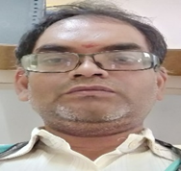 **Mr. M. Narasimhulu** M.Tech working as Assistant Professor in Computer Science and Department at Srinivasa Rumanian Institute of Technology, Anatapuramu. He has experience of 17 years in teaching profession and participated various FDP and training Programs. He completed NPTEL, EDU skill Certification Programs for the past 17 Years. He trained one SOC Program in Association Cisco Network Academy. He also trained Several Cisco Programs Since 2020.

**Feedback from students on the event:**

**Skill Oriented Course Outcomes: CCNAV7: Introduction to Networks**

The student will able to

1. Explain the advances in modern network technologies.
2. Implement initial settings including passwords, IP addressing, and default gateway parameters on a network switch and end devices.
3. Implement initial settings on a router and end devices.
4. Calculate an IPv4 subnetting scheme to efficiently segment your network.
5. Implement an IPv6 addressing scheme.
6. Configure switches and routers with device hardening features to enhance security.

**Feed Back on Particulars:**

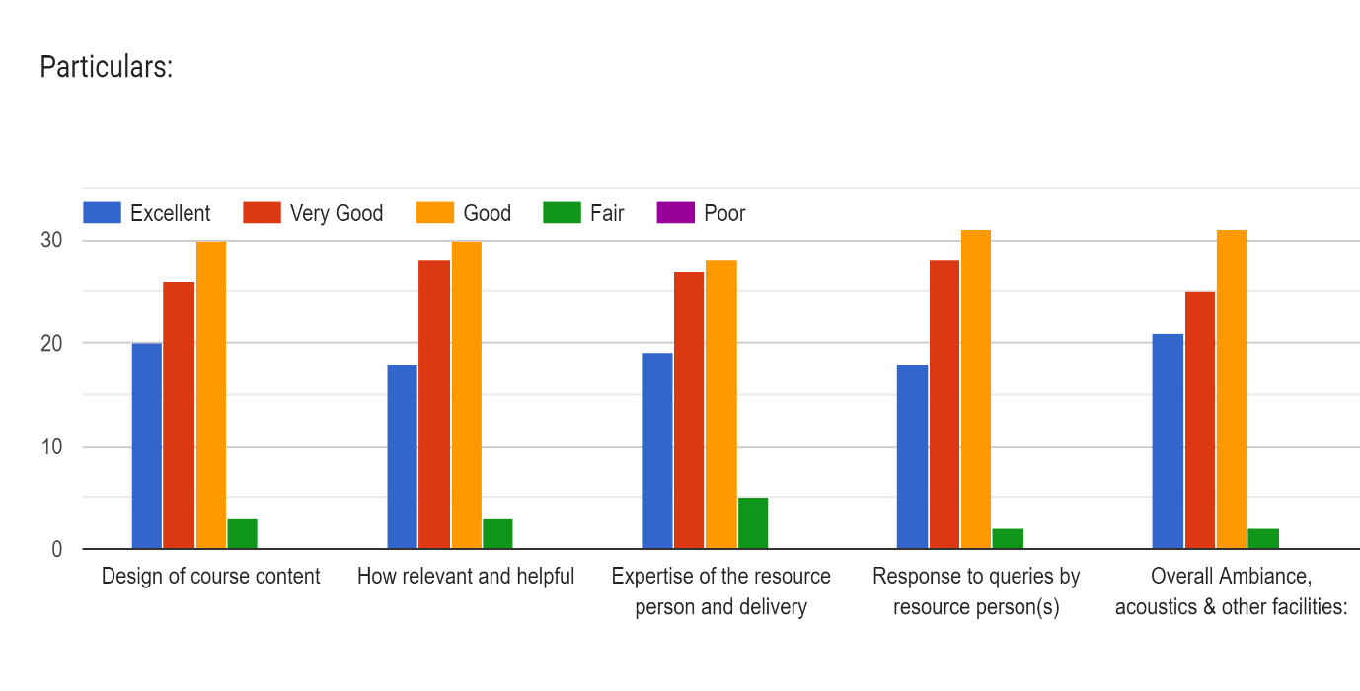

**Feedback on Program Outcomes/Program Specific Outcomes**

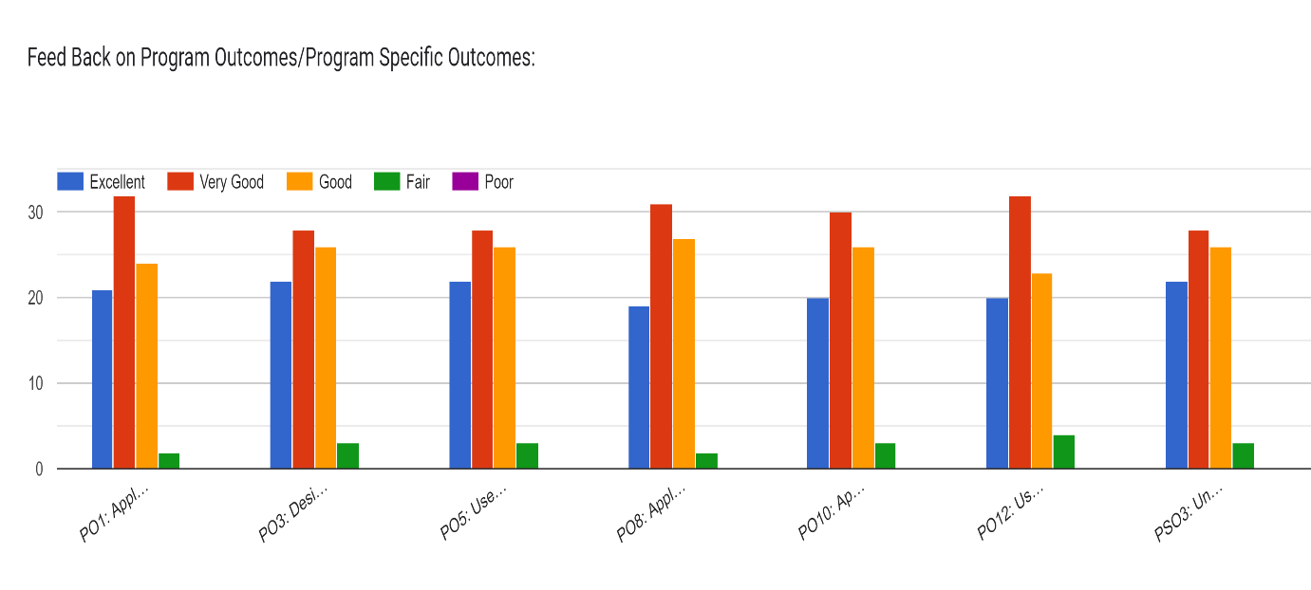

|  |  |  |  |  |  |  |  |  |  |  |  |  |  |  |  |
| --- | --- | --- | --- | --- | --- | --- | --- | --- | --- | --- | --- | --- | --- | --- | --- |
| **CO/PO** | **PO1** | **PO2** | **PO3** | **PO4** | **PO5** | **PO6** | **PO7** | **PO8** | **PO9** | **PO10** | **PO11** | **PO12** | **PSO1** | **PSO2** | **PSO3** |
| **CO1** | X |  |  |  |  |  |  |  |  |  |  | X |  |  | X |
| **CO2** | X | X |  |  | X |  |  |  |  | X |  | X |  |  | X |
| **CO3** | X |  |  |  | X |  |  |  |  | X |  | X |  |  | X |
| **CO4** | X |  |  |  | X |  |  |  |  | X |  | X |  |  | X |
| **CO5** | X |  |  |  | X |  |  | X |  | X |  | X |  |  | X |
| **CO6** | X |  |  |  | X |  |  |  | X |  |  | X |  |  | X |

Table 1: CO and PO Mapping for the “SOC-II CCNAV7: Introduction to Networks.”

**Event Photos:**

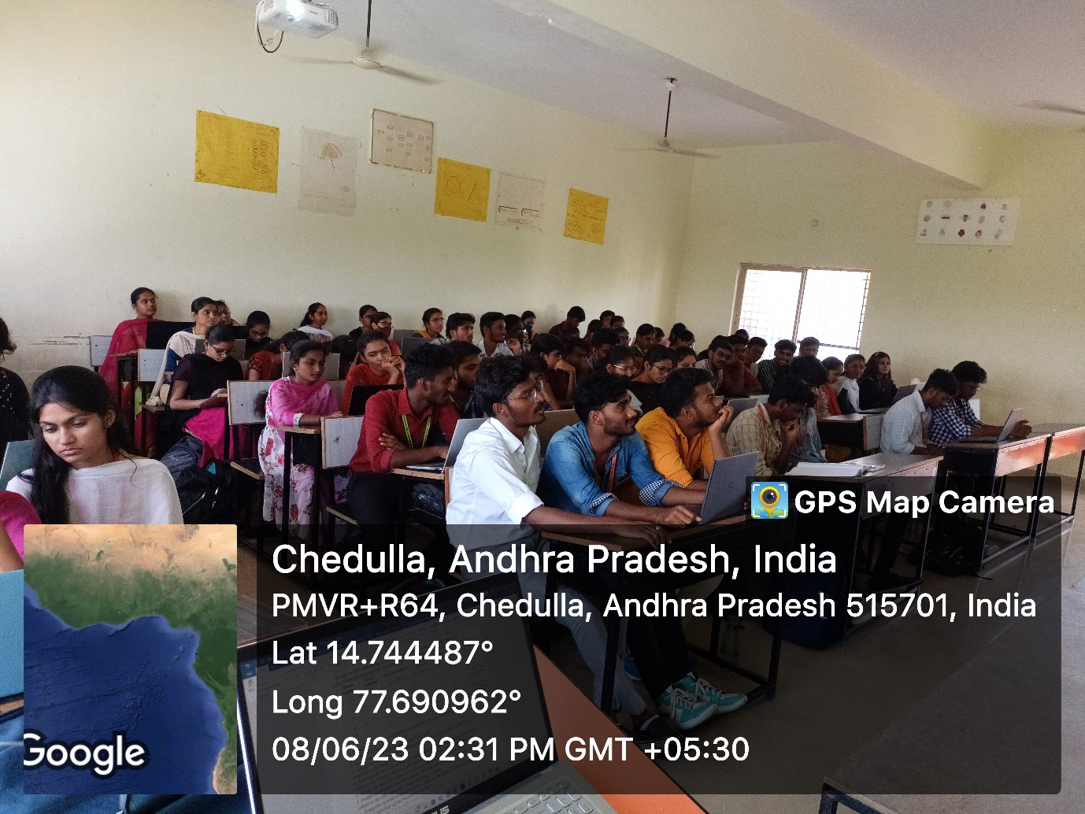

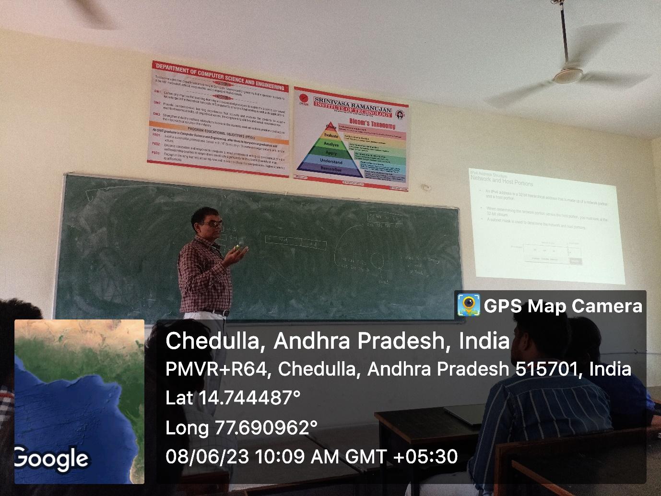

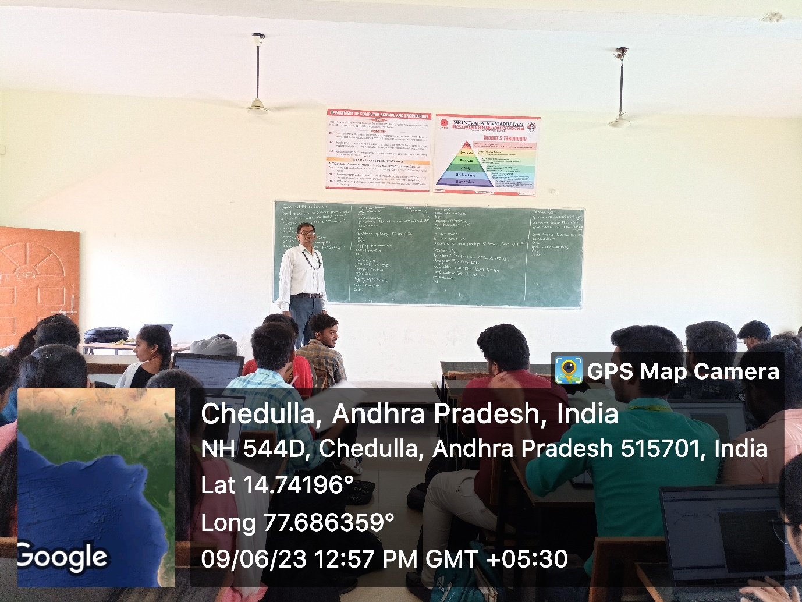

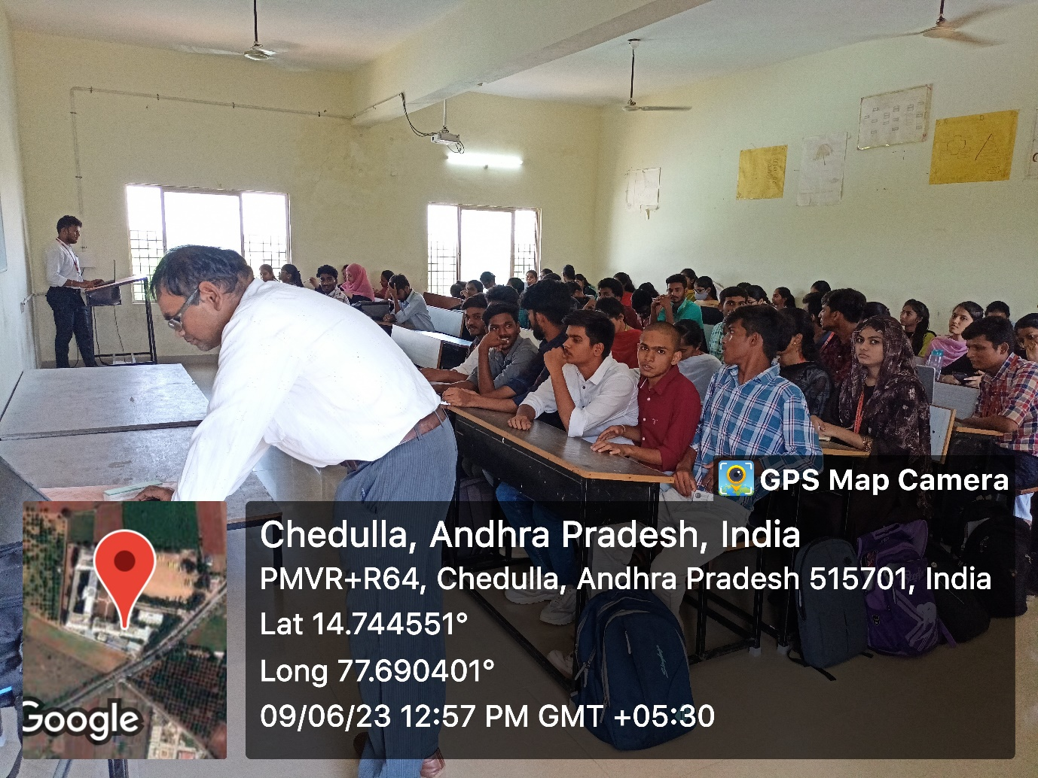

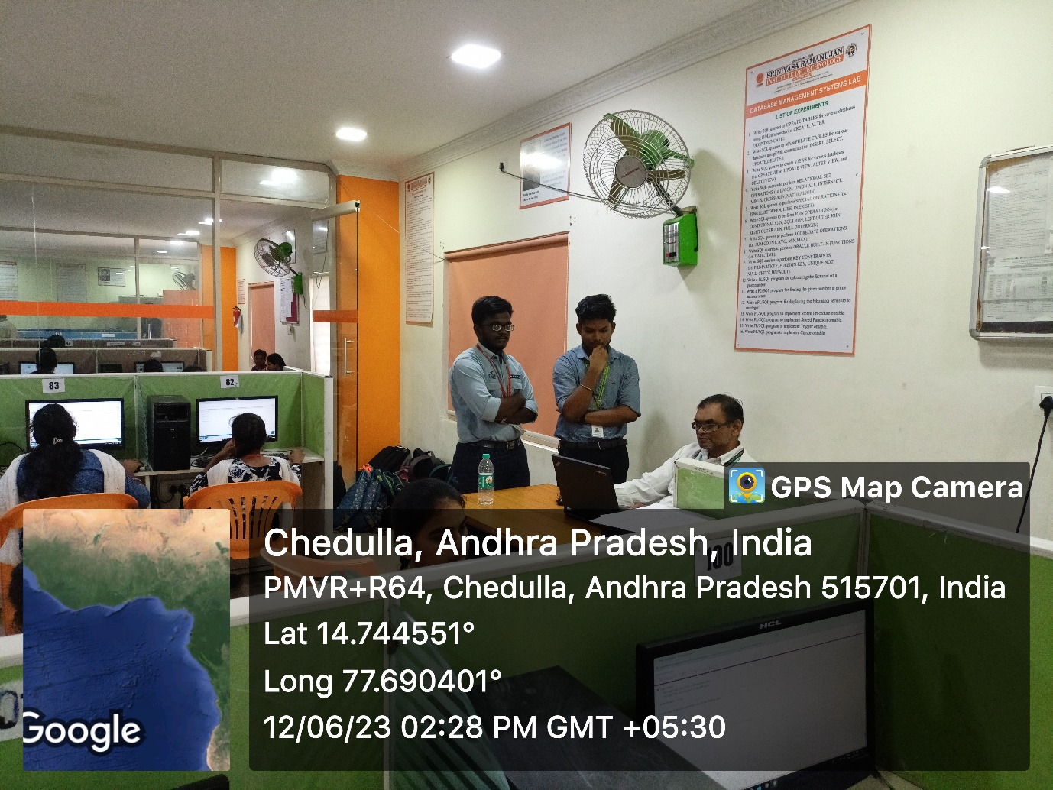

**Event Coordinator HOD**